**COMP 1200 MATLAB SYLLABUS**

**Instructor Information**

|  |  |
| --- | --- |
| **Name** | Rodrigo Sardiñas |
| **Office #** | Shelby 3127h |
| **Office hours** | TR 3pm-6pm |
| **Email** | Rodrigo.Sardinas@auburn.edu |

**Required**

1. Zybooks (primary text): Info in email. Key sent from bookstore. Enroll via Canvas. More later.
2. Laptop
   1. Recommended minimum specs:  
      2-core  
      8 gb ram  
      500 gb hard drive

**Optional**

1. USB thumb drive to store files and classwork

**Course Description**

To learn how to approach problem solving algorithmically and to learn fundamental computer programming concepts via a high-level language as a tool for solving engineering or science problems.

In this course we will learn basic programming concepts via the high-level programming language called MATLAB. We will first approach every problem from an algorithmic perspective, learning how to analyze and detail every step required to solve the problem. We will then demonstrate this knowledge by writing correct and appropriate MATLAB code to solve various problems given over the course of the semester.

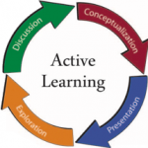

[This Photo](http://timothyharfield.com/blog/2012/12/12/active-learning-and-engagement-initiative-alei/) by Unknown Author is licensed under [CC BY-NC-ND](https://creativecommons.org/licenses/by-nc-nd/4.0/)

**NOTE**

This course will be an active-learning course, this semester. This means that there will be no (almost no) lectures given in class. I will post videos of the lectures that I would have given for you to watch BEFORE coming to class. In class, we will either work on exercises together, in groups, or we will take a quiz. I will attempt to structure the quizzes similar to the exams that you will take.

Quizzes are to be completed individually, while exercises will be done in groups

**Course Objectives**

This course is designed to give the student an introduction to algorithmic thinking and a basic understanding of using programming software (MATLAB software specifically) to solve problems.

* Given a problem statement, a student should be able to analyze and define the problem, and come up with a solution to the problem (in the form of a correct algorithm)
* Given an algorithm (or having devised one), the student will be able to translate that solution to (or implement that algorithm in) MATLAB code, resulting in a MATLAB program that will solve given problem
* Given source code written in MATLAB, the student will be able to abstract the code into an algorithmic form
* Given source code written in MATLAB, the student will correctly answer questions about the source code's purpose and about the syntax, semantics, and run-time results of the code
* Given incorrect source code written in MATLAB, the student will be able to locate and correct errors in the code

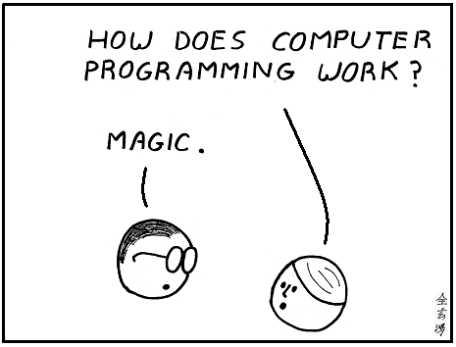

[This Photo](http://abstrusegoose.com/secretarchives/under-the-hood) by Unknown Author is licensed under [CC BY-NC](https://creativecommons.org/licenses/by-nc/3.0/)



[This Photo](http://www.duperrin.com/english/2015/03/06/coding-new-grail-smoke-mirrors/) by Unknown Author is licensed under [CC BY-NC-SA](https://creativecommons.org/licenses/by-nc-sa/2.0/)



[This Photo](http://graphicdesign.stackexchange.com/questions/21204/why-do-jpeg-files-blur-red-more-than-other-colors) by Unknown Author is licensed under [CC BY-SA](https://creativecommons.org/licenses/by-sa/3.0/)

**Topics Covered**

* Basic analytical and problem solving concepts
* Thinking algorithmically
* Computer programming fundamental concepts – variables, Boolean logic, functions, repetition, arrays, selection, programs
* MATLAB environment and structure
* MATLAB basics – variables, functions (built-in and user-defined), mathematical operations, input/output



[This Photo](http://www.iblognet.com/power-of-communication.html) by Unknown Author is licensed under [CC BY-NC-ND](https://creativecommons.org/licenses/by-nc-nd/3.0/)

**Communication**

**Contact Instructor or TA**

Office hours are listed in this document. Please email the instructor if you need to arrange an appointment outside of office hours.

Grades will ONLY be discussed in person with the Instructor.

When emailing the instructor OR your TA, you must include the following information in the subject of the email:

Course#

Assignment#/Exam#

**Failure to include this information could lead to your email not being processed or answered.**

**Communication from Instructor**

All announcements will be posted on the Canvas Announcement page. Any email correspondence will always be through official auburn email addresses only.

All assignments will be posted on the assignments page in Canvas.

You are responsible for all information presented in class, sent via announcements/emails, and posted on Canvas.

**Syllabus Modification**

The syllabus is subject to revision. The last modified date is always listed in the footer. A notification will be made in canvas and an announcement will be made during a lecture if the syllabus is modified.

**Attendance**

Please see the following link for a list of officially excused absences and more information on attendance in general, per Auburn University’s policies: <https://sites.auburn.edu/admin/universitypolicies/Policies/PolicyonClassAttendance.pdf>

I will not take attendance in class. **However, if a pop-quiz is given, there will be no makeup for it, even if it is an excused absence.**

**If you are absent on the date that an exam is given, you will be given a grade of 0 for that exam unless it is an official and excused absence. There will be no makeup for this grade.**

**Communication Devices and Electronics**

Communication devices (phones) should be turned off and set to silent before entering the classroom or a lab. No electronic devices are allowed during exams (phones, laptops, tablets, etc…).



[This Photo](https://cft.vanderbilt.edu/2012/09/grading-workshop/) by Unknown Author is licensed under [CC BY-NC](https://creativecommons.org/licenses/by-nc/4.0/)

**Grading Policies**

|  |  |  |
| --- | --- | --- |
| Zybook Activities | 10% | Grading Scale  A 90 – 100%  B 80 – 89%  C 70 – 79%  D 60 – 69%  F <60% |
| Assignments | 10% |
| Pop-Quizzes | 10% |
| Mid-term | 35% |
| Final | 35% |

**I WILL NOT curve or round your grade up at the end of the semester. Your final grade in this course is whatever is shown in Canvas as your final grade. An 89.9 is a B, NOT an A.**

**Zybook Activities**

Exercises/assignments from zybooks. Sections/chapters will be assigned and must be completed by due date for credit. **No grace period.**

**Assignments**

Assignments consist of programming work done in the Matlab environment. All assignments include a rubric (which is given to you at the same time the assignment is given) which indicate what you will be graded on.

**All assignments in this course are to be done individually. There are no group assignments in this course. The work submitted must be your own**.

**Pop-quizzes**

These will be given randomly throughout the semester. They will sometimes be actual quizzes, they will sometimes be activities that are taken up at the end of class. These are completed in class only. There is NO makeup for missed quizzes. I will drop the lowest two.

**Mid-term**

Comprehensive. Algorithms and MATLAB programming.

***Functional***

There will be sections for each fundamental programming concept we cover. These will typically consist of a short piece of code, followed by a question about the code.

***Functional/Logical***

There will be a longer section containing a short program. You must be able to analyze and understand the program, and answer questions about the purpose of the program, as well as how specific pieces of the program function.

*There will also be a section on algorithms.*

***Logical***

You will be given a description for an algorithm as well as most of the algorithm, minus a couple of steps, and you will be asked to “fill in missing steps”.

***Functional***

You will also be given a complete algorithm and will be asked to provide the corresponding MATLAB code for pieces of that algorithm.

Multiple-choice, scantron required (the blue one).

**Final**

Same as midterm. Comprehensive.

**Discussing Grades**

All grade discussions must be held in person. Questions regarding grading matters will NOT be accepted by email.

Grades will be recorded on Canvas in a timely manner. Check your grades on Canvas “Grades” page. See the comments section for grader comments. It is your responsibility to contact the teaching assistant who graded your work with questions about your assignment grades or the instructor about an exam grade. If you are unable to resolve grading questions with the TA, then you should contact me.

You have SEVEN (7) DAYS AFTER an ASSIGNMENT or a TEST GRADE is POSTED to question the grade. After that time, the grade will stay as it is. There are no exceptions.

**Late Assignments and Missed Exams**

Each day an **assignment** is late, 10% will be deducted from the final grade, with a 0 being given after the third day.

Any missed exams, in the absence of approved documentation will be given a zero score.

Any missed pop-quizzes will be given a zero score.

All zybooks assignments will be graded per completion by due date. Any work completed after the due date will not go towards a zybooks grade.

**Plagiarism and Cheating**

Always document all sources of help for assignments. Any form of plagiarism will be reported to the Office of the Provost, per Auburn University’s Academic Honesty policy and met with a grade of 0 on the first occurrence. Any subsequent occurrences will result in a failing grade for the course.

If a student is caught cheating, the incident will be reported to the Office of the Provost, per Auburn University’s Academic Honesty Policy, and the assignment/exam will be given a grade of 0. Any subsequent offence will result in a failing grade for the course.

Please see the following link for more on Auburn’s Academic Dishonesty Policy:

<https://sites.auburn.edu/admin/universitypolicies/Policies/AcademicHonestyCode.pdf>

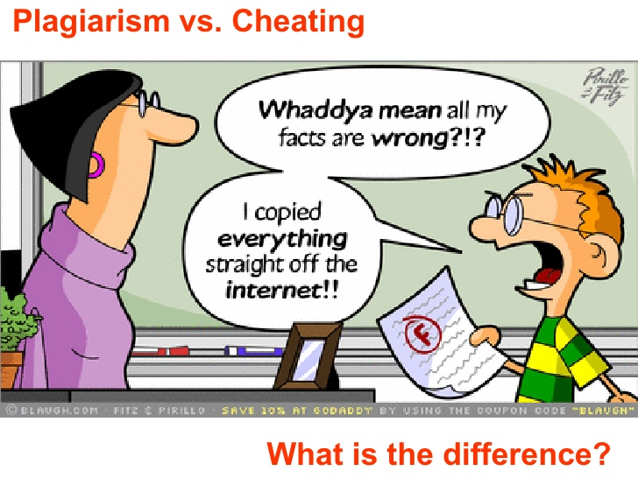

[This Photo](http://www.slideshare.net/maryaliceosborne/plagiarism-vs-cheating-what-is-the-difference-presentation) by Unknown Author is licensed under [CC BY-NC-SA](https://creativecommons.org/licenses/by-nc-sa/2.5/)



[This Photo](http://www.educadoresdigitales.org/2010/10/no-me-copies-no-es-justo-lo-que-los.html) by Unknown Author is licensed under [CC BY-NC](https://creativecommons.org/licenses/by-nc/3.0/)

**Software and Assignments**

**In Class Exercises**

**Shell**

If you are a windows user, I recommend downloading git for windows for in-class exercises. Link below:

<https://gitforwindows.org>

If you are a mac user, you already have a client for this.

**Cisco VPN**

You will need to have the cisco vpn installed to use the virtual matlab program and possibly to access your H drive. Instructions at the following link:

Download here: <https://cws.auburn.edu/oit/auinstall>

Select the appropriate operating system.

Instructions here: <https://auburn.service-now.com/it?id=kb_article&sys_id=1be035cfdb96f2002fb0fba9bf96196a>

**H Drive Access:**

If you are a windows user. I recommend getting winscp. Must connect to Cisco VPN first.

Download here: <https://cws.auburn.edu/oit/auinstall>

Instructions here: <http://www.eng.auburn.edu/~cross/comp1210/Lab/Using_WinSCP_to_Transfer_Files.pdf>

If you are a mac user, you can use Cyberduck.

Download here: <https://cws.auburn.edu/oit/auinstall>

Instructions here: <http://www.eng.auburn.edu/~cross/comp1210/Lab/Using_Cyberduck_to_Transfer_Files.pdf>

**Virtual Matlab Software.**

You will need to be logged onto the vpn.

Instructions here: <http://eng.auburn.edu/admin/ens/helpdesk/off-campus/vdi.html>

**COURSE SOFTWARE AND COMPUTING FACILITIES**

The MATLAB software is installed on the computers in College of Engineering (COE) labs for you to use; see http://eng.auburn.edu/admin/ens/labs/index.html. MATLAB is also available in many other campus computer labs; see http://www.auburn.edu/oit/labs/. If you wish, you may also purchase a copy of the software and do all work on your own personal computer. The MATLAB software may be purchased at the AU Bookstore or mathworks.com. NOTE: On home football weekends, the engineering computer labs will the CLOSED from midnight Friday to noon Sunday.

**After Hours Building Access**

For access to Shelby or other COE buildings after hours, you will need to swipe your ID at the exterior doors. See http://spider.eng.auburn.edu/problem/cardswipe.php NOTE: For non-engineering students, this access will be cancelled at the end of the semester.

**Important Dates**

|  |  |  |
| --- | --- | --- |
| **Aug 27 – Sep 10** | **$100 drop fee per course during these dates** | **Mon - Mon** |
| **Sep 3** | **Labor Day** | **Mon** |
| **Sep 10** | **Drop Course Penalty Days - *Last day to drop with no grade assignment + potential tuition refund.*** | **Mon** |
| **Oct 10** | **Midterm Exam** | **Wed** |
| **Oct 11 - 12** | **Fall Break** | **Thu - Fri** |
| **Nov 2** | **Drop Course Penalty Days**  **-*last day to drop with no grade penalty “W” assigned.*** | **Fri** |
| **Nov 19 - 23** | **Thanksgiving Break** | **Mon-Fri** |
| **Dec 5** | **Final Exam** | **Wed** |

**Special Accommodations**

Students who need accommodations are asked to arrange a meeting with your instructor as soon as possible. If you have a conflict with my office hours, an alternate time can be arranged. To set up this meeting, please contact me by email. If you do not have an Accommodation Memo but need accommodations, make an appointment with The Program for Students with Disabilities, 1244 Haley Center, 844-2096 (V/TDD).

Please see the following link for more information on accommodations:

<https://sites.auburn.edu/admin/universitypolicies/Policies/ADAAccommodationsPolicy.pdf>



[This Photo](http://commons.wikimedia.org/wiki/File:AH-Software_logo.svg) by Unknown Author is licensed under [CC BY-SA](https://creativecommons.org/licenses/by-sa/3.0/)

**So what is my actual grade in this course? How do I calculate a weighted average? And what am I actually seeing in Canvas?**

When a weighted average is used to obtain your grade for a course, each category of material represents a percentage of your overall points. Let’s look at an example.

Zybooks = 10%

Assignments = 10%

Pop-Quizzes = 10%

Midterm = 35%

Final = 35%

As such, until you have a grade for EVERY category, it is impossible to accurately display what your actual grade is. What canvas will instead do, is show you a percentage based on what you have completed (vs your actual grade). Let’s take a couple of examples below.

Suppose your grades for each category were the following:

Assignments = 80

Pop-Quizzes = 90

Midterm = 85

To calculate the actual score, you would do the following:

(80 * 10%) + (90 * 10%) + (85 * 35%) 🡨 It is impossible for these to add up to 100, even if the grades for each category were 100%. Instead we have:

8 + 9 + 29.75 = 46.75

Since you don’t have grades for the other two categories, you can’t calculate a correct weighted average. Instead, you can see from the example above that your current grade is a 46 (F).

This is not what canvas will show you. Canvas will simply calculate your grade based on the total percentages of assignments you have completed. Let’s take a look at this same example.

Currently, you have earned 46.75 points in the class but not 46.75 points out of 100 (according to canvas). If we add up the percentages for each category with a grade we end up with:

10 + 10 + 35 = 55% or 55 points.

This is what Canvas will show you:

46.75/55 = 85 (B)

So in Canvas, you will see a grade of 85, when you actually have only 46.75 points out of 100 (46.75 F).

If you were to receive a grade for another category, this would change again. Suppose, in addition to the grades above, you now earn a 90 on the zybook activities. Now you have

46.75 + (90 * 10%) = 46.75 + 9 = 55.75 (F)

This is what Canvas will show you:

55.75/65 = 85.7 B



[This Photo](http://profslusos.blogspot.com/2013/08/para-quando-publicitacao-das-listas-de.html) by Unknown Author is licensed under [CC BY-SA](https://creativecommons.org/licenses/by-sa/2.5/)



[This Photo](http://www.justintarte.com/2014/09/is-your-gradebook-supportive-of-learning.html) by Unknown Author is licensed under [CC BY](https://creativecommons.org/licenses/by/4.0/)